CI/CD Mobile Setup AWS Codebuild

Owner | Hadyan Mulya Mafazi
Engineer | Sofware Engineer  - …  Quality Engineer  - …
Approval
Status Work | DEVELOPMENT / STAGING

Revision History
Version | Date | Author | Description
1.0.0

Goal

- Setup Gradle build for mobile apps in AWS Codebuild
- Sent the APK to firebase distribution
- Setup slack notif

Steps

Create project

- Fill the project name ( ex : app-firebase)

- Choose source provider Github

- Pick project github repository (ex : retailer-app)

- Choose git clone depth to Full

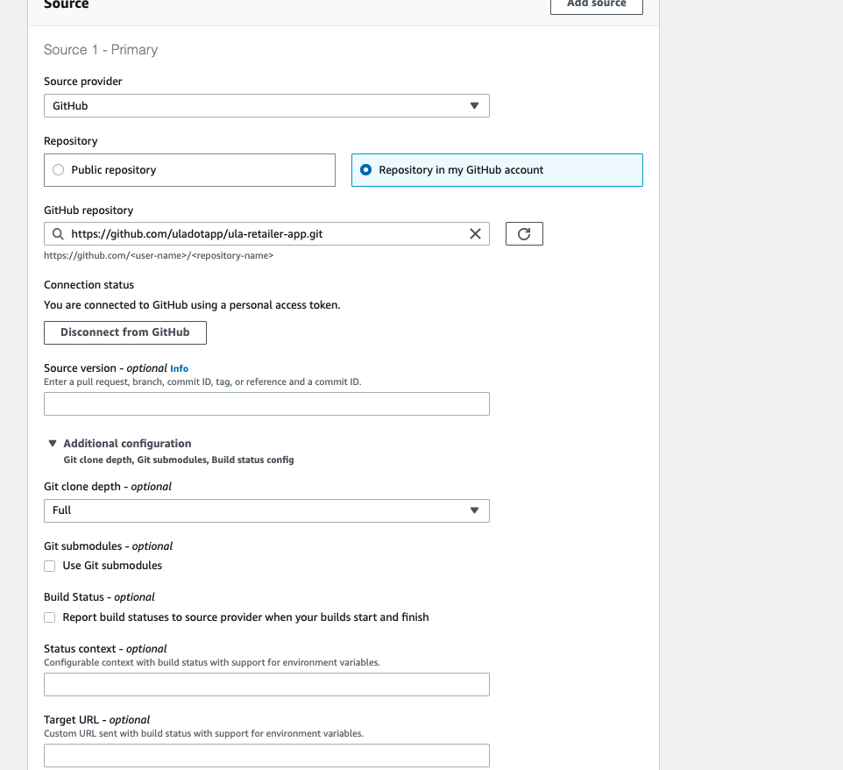

- Choose Operating system Ubuntu

- Choose Existing role dev-iam-role-cb (DEV) and stg-iam-role-cb (STG)

- In Primary source webhook events Check Rebuild every time a code change is pushed to this repository

- Choose Event Type PUSH

- In HEAD_REF Fill : refs/heads/development ( dev ) or refs/heads/release/.* (stg)

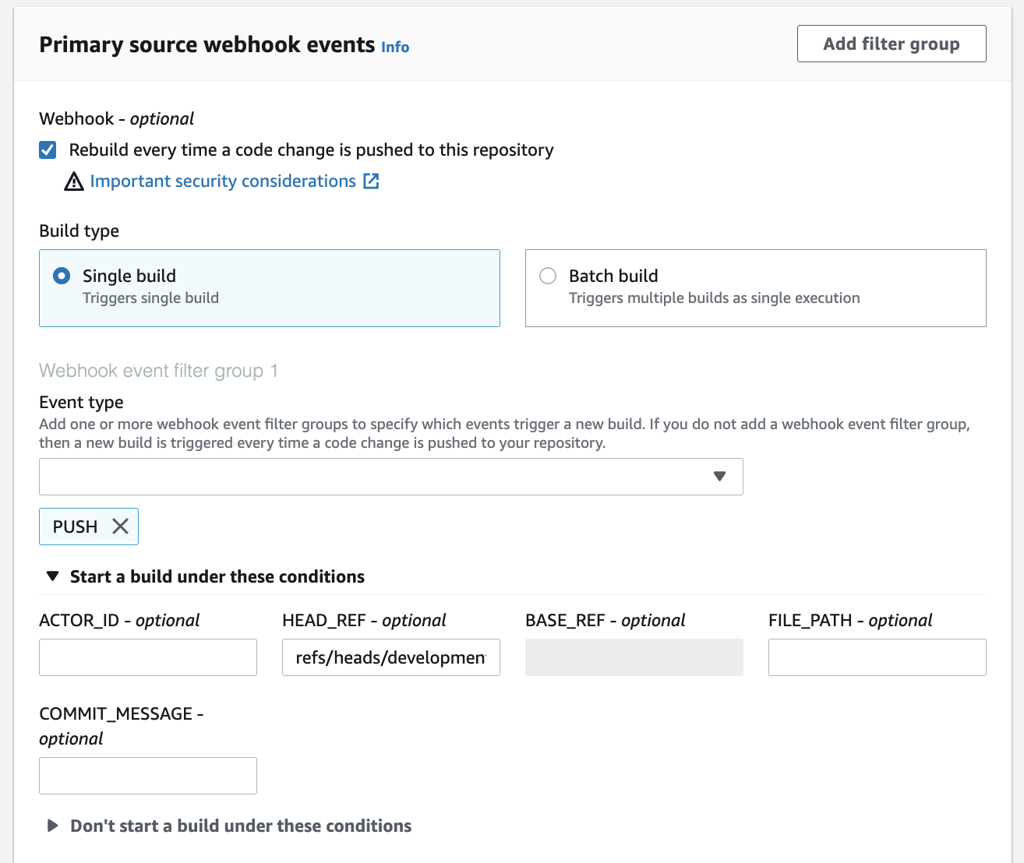

- Pick compute : 15 GB memory, 8 vCPUs

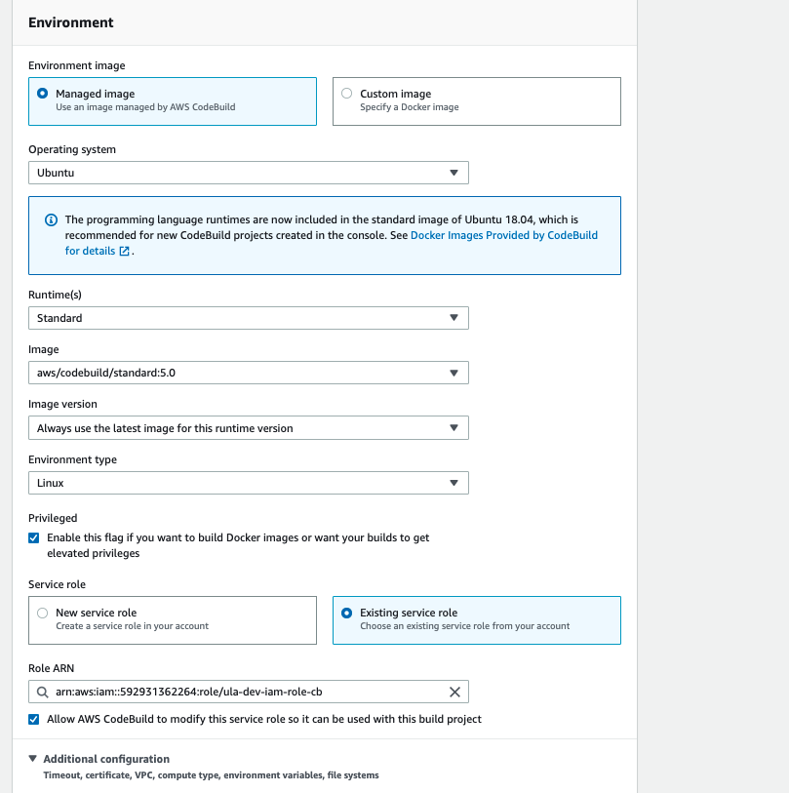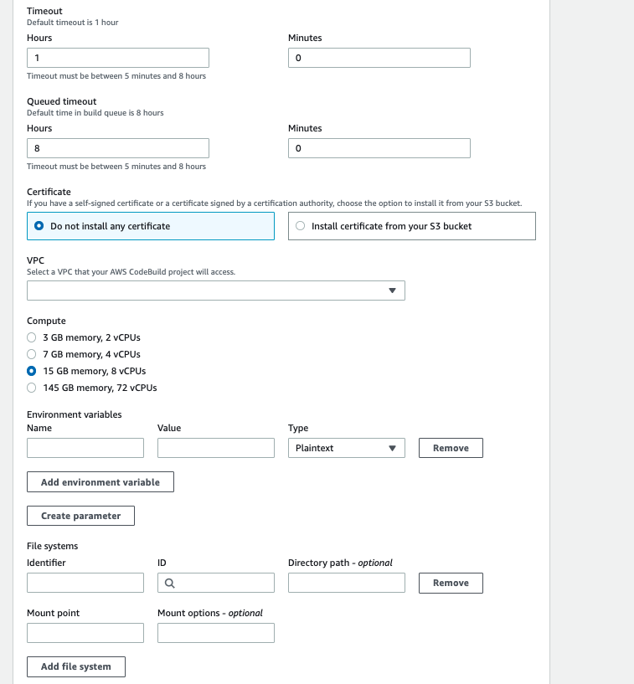

- Buildspec file ( ex : buildspec-retailer-app-cicd-stg.yml )

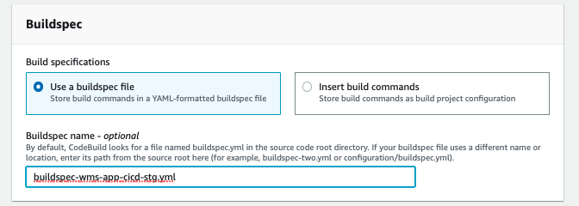

- Enable cache to improve build time ( optional )

Notes : please create folder in bucket dev-codebuild-cache ( dev) and dev-codebuild-cache (stg)

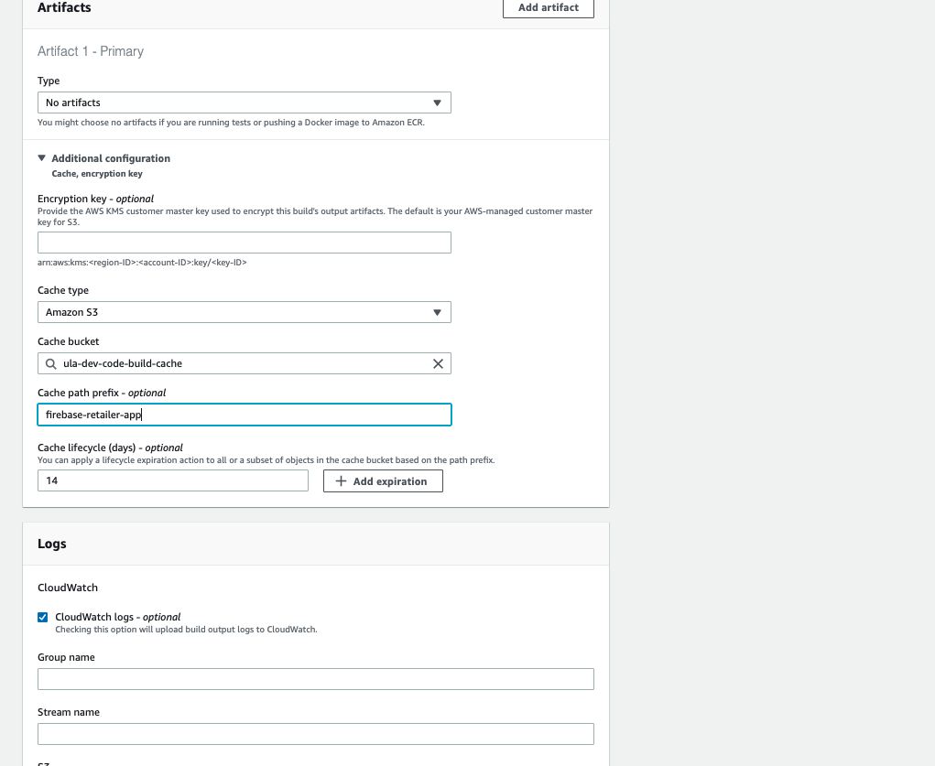

Setup Buildspec and Environment Variables

- Create Buildspec yml in the project

Example in sales app (dev)

version: 0.2
env:
shell: bash
git-credential-helper: yes
variables:
GROUPS: testers
FILE: app/build/outputs/apk/dev/debug/app-dev-debug.apk
parameter-store:
APPID : /stage/secret/sales-app/FIREBASE_APP_ID
TOKEN : /stage/secret/firebase/TOKEN
phases:
install:
runtime-versions:
java: corretto11
commands:
- apt update
- n 14.18.3
- yarn global add firebase-tools
build:
on-failure : ABORT
commands:
- sudo mkdir /usr/lib/android-sdk
- export ANDROID_SDK_ROOT=/usr/lib/android-sdk
- wget https://dl.google.com/android/repository/commandlinetools-linux-8092744_latest.zip -P ~/
- unzip ~/commandlinetools-linux-8092744_latest.zip -d /usr/lib/android-sdk
- mkdir -p /usr/lib/android-sdk/temp-tools
- mkdir -p /usr/lib/android-sdk/cmdline-tools/tools
- sudo cp -r /usr/lib/android-sdk/cmdline-tools/* /usr/lib/android-sdk/temp-tools/
- sudo mv /usr/lib/android-sdk/temp-tools/* /usr/lib/android-sdk/cmdline-tools/tools/
- yes | /usr/lib/android-sdk/cmdline-tools/tools/bin/sdkmanager --update
- yes | /usr/lib/android-sdk/cmdline-tools/tools/bin/sdkmanager --licenses
- git fetch --depth 1 origin $CODEBUILD_WEBHOOK_HEAD_REF
- echo "Build Development APK `date`"
- set -eo pipefail
- exit_status=0
- bash ./gradlew assembleDev --stacktrace || exit_status=$?
- |
if [ $exit_status != 0 ]; then
source slack_notif/failed-dev.sh
echo "failed"
exit 1
fi
- echo "List Files `date`"
- ls -lrt app/build/outputs/apk/dev/debug/
- echo "Upload Development artifact to Firebase App Distribution `date`"
- ls
- source entrypoint.sh
post_build:
commands:
- source slack_notif/success-dev.sh

cache:
paths:
- '~/.gradle/caches/**/*'
- 'build/**/*'

Notes : please modify the APPID and GROUPS (for testing) coordinate with mobile engineer

- Setup the APP ID Firebase in the SSM parameter store ( EX : //stage/secret/sales-app/FIREBASE_APP_ID)

Notes : please coordinate with mobile engineer PIC regarding APP ID

- Please make sure other environment variables also if need to put

EX : keystore, endpoints

Reference :

Setup Slack Notif

- Determine slack channel as notification result

- Create the webhook for that channel ( If don’t have the webhook before)

- Add New webhook to workspace

- Create folder slack_notif in project

- Create 4 files include : failed-dev.sh, failed-stg.sh, success-file.sh, success-stg.sh

